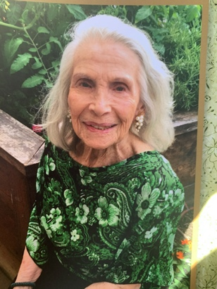

Sylvia Estelle Mines was laid to rest at Hillside Memorial Park on November, 27, 2020 by her loving son, Steven Mines (Paula Mines), her devoted daughter Terri Fortner (Scott Fortner) and her admiring grandchildren: Ashley Mines (Brad Moore), Rebecca Mines (Lee Nunley), Lauren Fortner, and Jenna Fortner. The selfless, unconditional love and indominable spirit with which she met each day of her full and fascinating life will serve to comfort and inspire the family who will proudly carry forward her memory.

Sylvia was born to Jack and Rae Goldberg in Los Angeles California on February 28, 1922, as the youngest sibling to brother, Milton, and sister, Regina. She adored her entrepreneurial father and as a young girl would tag along with him to the Taxi Dance Hall he owned. It was there that she first discovered her love of dance and performing as she sang along to all the songs the band played and watched the couples glide around the room. When she was not indulging her more whimsical creative side dreaming in the company of adults, Sylvia was likely caked with a little dirt as the fearless tomboy aspects of her personality tended to win out when engaging with her peers. Never one to let her age or gender limit her, she was known for confronting the older boys in the neighborhood, especially when it came to protecting her older brother Milton, whom she loved fiercely.

Shortly after graduating from Dorsey High School in Los Angeles, Sylvia began a career as a performer. Taking to the road with her tumbling act, Sylvia quickly distinguished herself as one of the most acclaimed acrobatic and contortionist performers in the country. Her talent enabled her to travel widely and mingle with all sorts of interesting characters including, Peggy Lee and Benny Goodman. She adopted the stage name Sylvia Stanton and expanded her act, performing as Sylvia Stanton of the Stanton Sisters. In addition to her acrobatics Sylvia expanded her talents into other areas of entertainment: she appeared in Continental Pictures Inc.’s 1944 feature film “Teen Age”, opened a dance studio in Hollywood, and performed as a comedienne in nightclubs.

While performing in Mississippi, Sylvia met a handsome Airforce officer, Sam Mines, who she went on to marry in August of 1945. Sylvia and Sam were married for 10 years and had two children together, for whom she would take sole responsibility following their separation. As a single mom Sylvia worked tirelessly to ensure that her children would not want for anything growing up. While the tasks she took on to provide for her family may have been less glamorous than those of her early career, Sylvia was a dedicated worker no matter the job, instilling the importance of a great work ethic in her children. Through her role as a mother, Sylvia’s exceptional baking skills became clear, as did her artistic skills, as evidenced in her elaborate cake decorations. In addition to caring for her children, Sylvia went out of her way to provide emotional support for both her father and his brother Sol in their later years. Her dedication to providing for her family, combined with the entrepreneurial spirit she inherited from her father, led her to pursue a number of creative side-hustles, including making frequent use of her artistic talents to create and sell goods in LA’s large swap-meets.

In addition to being a loving daughter, sister, and mother, Sylvia took great joy in expanding her role to include grandmother. Sylvia relished hosting large family events, where all attendees happily ate her magically delicious meals. To her four granddaughters the “girls” she was “Grandma Stars” (oddly a nick name she was given by association with her pet cockatoo, Star, when the girls were very young and did not yet know about her past as a performer). She always had a sweet treat waiting for them and some amazing story about something she did or experienced which she would tell them about completely nonchalantly, in a way that made it feel like the world was full of remarkable moments, like greatness was inevitable, and of course that for her girls anything was possible.

Her favorite saying was “Do What you can with what you’ve got and hope for the best”. Her family will be eternally grateful for everything she did with what she was given and feel lucky to have been graced by the best.

